|  |  |  |  |
| --- | --- | --- | --- |
| Date: | **15-07-2020** | Name: | **Varun G Shetty** |
| Course: | **Coursera** | USN: | **4AL17EC093** |
| Topic: | * Mathematics for machine learning: Linear Algebra | Semester & Section: | **6th & ‘B’** |
| GitHub Repository: | **Varunshetty4** |  |  |

**Report-**

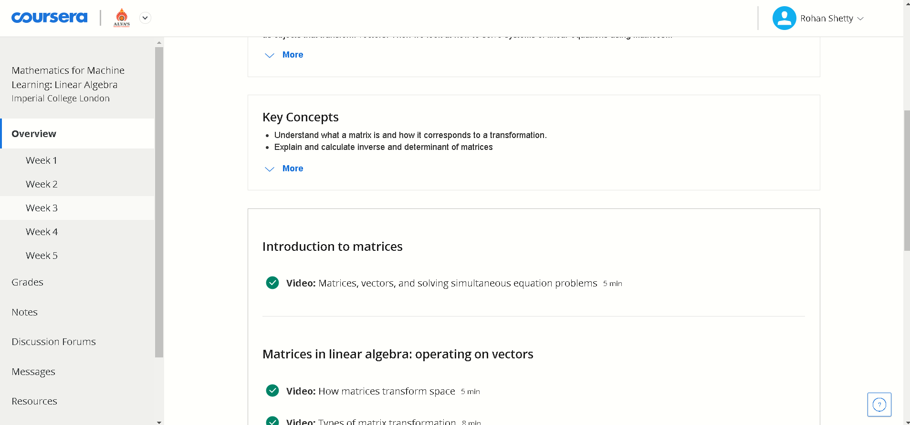

Matrix is an arrangement of numbers into rows and columns. Make your first introduction with matrices and learn about their dimensions and elements. A matrix is a rectangular arrangement of numbers into rows and columns. For example, matrix A has two rows and three columns.

The mathematical concept of a matrix refers to a set of numbers, variables or functions ordered in rows and columns. Such a set then can be defined as a distinct entity, the matrix, and it can be manipulated as a whole according to some basic mathematical rules.

Matrices can be used to compactly write and work with multiple linear equations, referred to as a system of linear equations, simultaneously. Matrices and matrix multiplication reveal their essential features when related to linear transformations, also known as linear maps. A matrix is a collection of numbers arranged into a fixed number of rows and columns. Usually the numbers are real numbers

. In general, matrices can contain complex numbers but we won't see those here. In geology, matrices are used for making seismic surveys. They are used for plotting graphs, statistics and also to do scientific studies and research in almost different fields. Matrices are also used in representing the real world data's like the population of people, infant mortality rate, etc.